**Design Thinking Project Workbook**

**Don't find customers for your product but find products for your customers**

**1. Team**

**Team Name:NEBULA**

**Team Logo (if any):**

**Team Members:**

1. [Tanmay 2320040093]
2. [Akshay 2320040128]
3. [Chaitanya 2320040003]

**2. Problem/Opportunity Domain**

**Domain of Interest: The specific industry or field where your innovative idea will be applied.**

**Smart Home Automation**

* **Home Management: The assistant can control smart home devices (e.g., lights, thermostats) through voice commands, creating a more integrated living environment.**
* **Security Monitoring: It can alert homeowners about security issues or unusual activities detected through voice recognition.**

**Description of the Domain: A brief overview of the key elements, challenges, and opportunities within the domain.**

**Key Elements**

* **Sustainability: The project emphasizes reducing environmental impact by promoting sustainable building practices and materials.**
* **People-Centric Design: It aims to improve individual well-being and social cohesion through designs that prioritize user experience and community needs.**

**Why did you choose this domain?: The personal or strategic reasons for selecting this domain, such as passion, market potential, or solving a specific problem.**

**Urgency of Sustainability**

* **Environmental Impact: The construction and urban planning sectors are significant contributors to carbon emissions and resource consumption. Focusing on sustainability in this domain is crucial for mitigating climate change and promoting environmental stewardship.**
* **Regulatory Pressures: Governments worldwide are implementing stricter regulations aimed at reducing the environmental footprint of buildings. This creates a pressing need for innovative solutions that comply with these regulations.**

**2. Human-Centric Design**

* **Quality of Life: The Built Environment directly affects people's quality of life, including health, safety, and well-being. By prioritizing human-centric design, the project aims to create spaces that enhance social interaction and community engagement.**
* **Inclusivity: There is an increasing demand for designs that cater to diverse populations, including people with disabilities and marginalized communities. This focus aligns with broader societal goals of inclusivity and equity.**

**3. Problem/Opportunity Statement**

**Problem Statement: A clear and specific articulation of the problem, outlining its importance.**

**The NEBULA project aims to address two major challenges facing the built environment:**

1. **Becoming more sustainable to deliver an efficient answer to climate change and biodiversity reduction**
2. **Becoming more "people-centric" to improve individual well-being and social cohesion**

**Problem Description: A concise explanation of the issue or challenge that needs to be solved.**

1. **Sustainability: The construction and urban planning sectors significantly contribute to environmental degradation through high carbon emissions, resource depletion, and waste generation. There is an urgent need to adopt innovative, sustainable building practices that minimize ecological impact and promote energy efficiency.**

**Context (When does the problem occur): The specific situations or conditions under which the problem arises.**

**Urbanization**

* **Rapid Population Growth: As cities expand and populations increase, the demand for housing and infrastructure rises, often leading to hasty construction practices that overlook sustainability.**
* **Inadequate Planning: Many urban areas are developed without comprehensive planning, resulting in poorly designed spaces that do not meet the needs of residents.**

**Alternatives (What does the customer do to fix the problem): Existing solutions or actions taken by customers to address the issue.**

* **Eco-Friendly Materials: Customers are increasingly opting for products made from sustainable materials, such as recycled or biodegradable options. This choice helps reduce waste and the demand for new raw materials.**
* **Energy Efficiency: Many consumers look for energy-efficient appliances and building materials, which contribute to lower energy consumption and reduced environmental impac**

**Customers (Who has the problem most often): The primary group of individuals or organizations affected by the problem.**

**Conscious Consumers: A growing segment of consumers, particularly younger generations, prioritize sustainability in their purchasing decisions. They actively seek out brands that demonstrate a commitment to environmental responsibility and ethical practices. Research indicates that around 64% of consumers express high concern for sustainability, influencing their shopping habits significantly**

**Emotional Impact (How does the customer feel): The emotions or frustrations experienced by the customer due to the problem.**

* **Limited Choices: Consumers often feel frustrated by the lack of sustainable options available in the market. They may struggle to find products or buildings that align with their values, leading to feelings of helplessness.**
* **Complexity of Information: The overwhelming amount of information regarding sustainability can lead to confusion. Customers may find it challenging to discern which products are genuinely sustainable versus those that are merely marketed as such (greenwashing)**

**Quantifiable Impact (What is the measurable impact): The measurable effects of the problem, such as financial losses or time wasted.**

* **Insurance Costs: The financial burden of climate-related disasters has escalated significantly, with insurance payouts reaching approximately $845 billion globally in recent years due to extreme weather events. This figure underscores the rising costs associated with inadequate sustainable practices in construction and urban planning.**
* **Economic Damage from Disasters: The total economic damage from natural disasters has amounted to about $2.98 trillion over the last decade, indicating substantial financial losses linked to climate change and poor infrastructure resilience.**

**Alternative Shortcomings (What are the disadvantages of the alternatives): The limitations or downsides of the current solutions customers use.**

* **Eco-friendly products often come with a premium price tag, making them less accessible to many consumers. This can lead to frustration and limit the adoption of sustainable options.**
* **Businesses face substantial initial expenses when implementing eco-friendly practices, such as installing new devices and obtaining certifications. While these costs may be recovered in the long run, they can be a significant barrier to entry.**

**Any Video or Images to showcase the problem: The evidence in the form of video or image).**

**Provide link if available**

**3. Addressing SDGs**

**Relevant Sustainable Development Goals (SDGs): Identify which of the 17 SDGs are directly impacted by the problem or opportunity.**

**SDG 9: Industry, Innovation, and Infrastructure**

* **NEBULA encourages innovation in construction technologies and sustainable materials, fostering resilient infrastructure. This goal focuses on building resilient infrastructure, promoting inclusive and sustainable industrialization, and fostering innovation.**

**How does your problem/opportunity address these SDGs?: Describe how solving the problem or leveraging the opportunity will contribute to achieving one or more SDGs.**

**Clean Water and Sanitation**

**By promoting sustainable construction practices, NEBULA encourages the implementation of efficient water management systems in buildings. This can lead to reduced water consumption and improved sanitation facilities, ensuring better access to clean water for communities.**

**4. Stakeholders**

Answer these below questions to understand the stakeholder related to your project

1. **Who are the key stakeholders involved in or affected by this project?**

**Innovation Clusters**

* **Regional Clusters:** Specific clusters such as BUILD INN (Basque Country, Spain) and ODEYS (Occitanie, France) serve as co-designers and beta testers for the project's services, facilitating local innovation.
* **Emerging Clusters:** NEBULA aims to support additional clusters throughout Europe, enhancing their maturity and capacity to implement sustainable solutions.

1. **What roles do the stakeholders play in the success of the innovation?**

**Project Coordinators and Partners**

* **Leadership and Management:** Organizations like DOWEL Innovation lead the project, ensuring that objectives are met and resources are allocated effectively. Their role is crucial in coordinating activities among different stakeholders and maintaining focus on project goals.
* **Technical Expertise:** Partners such as TECNALIA provide specialized knowledge and technical support, which is essential for developing innovative solutions and ensuring that they are viable and effective.

1. **What are the main interests and concerns of each stakeholder?**

* **Interests:**
  + Successful implementation and management of the NEBULA project.
  + Building a robust network of Innovation Clusters to enhance collaboration and knowledge sharing.
  + Achieving project goals related to sustainability and human-centric design.

1. **How much influence does each stakeholder have on the outcome of the project?**

**Project Coordinators and Partners**

* **Influence Level: High**
* **Description: As the primary organizers and managers of the NEBULA project, coordinators like DOWEL Innovation have substantial influence over project direction, resource allocation, and strategic decision-making. Their ability to foster collaboration among stakeholders is crucial for achieving project objectives.**

1. **What is the level of engagement or support expected from each stakeholder?**

* **Expected Engagement Level:** Leading
* **Description:** Coordinators and partners are expected to take a proactive role in driving the project forward. Their engagement includes strategic decision-making, resource allocation, and fostering collaboration among all stakeholders.

1. **Are there any conflicts of interest between stakeholders? If so, how can they be addressed?**

**Conflict:** Financial institutions may prioritize investments that yield immediate returns, while project coordinators and innovation clusters might focus on long-term sustainability goals that require upfront investment.

1. **How will you communicate and collaborate with stakeholders throughout the project?**

**Communication Methods:** Regular meetings, progress reports, and updates via email and project management too

1. **What potential risks do stakeholders bring to the project, and how can these be mitigated?**

**Risk:** Different stakeholders may have competing priorities or goals, leading to conflicts that can derail the project. For example, financial institutions may prioritize short-term returns, while innovation clusters focus on long-term sustainability.

* **Mitigation:** Foster open communication and collaboration to align stakeholder interests. Establish clear objectives and decision-making processes that balance the needs of various stakeholders. Utilize conflict resolution techniques when necessary.

**5. Power Interest Matrix of Stakeholders**

**Power Interest Matrix: Provide a diagrammatic representation of Power Interest Matrix**

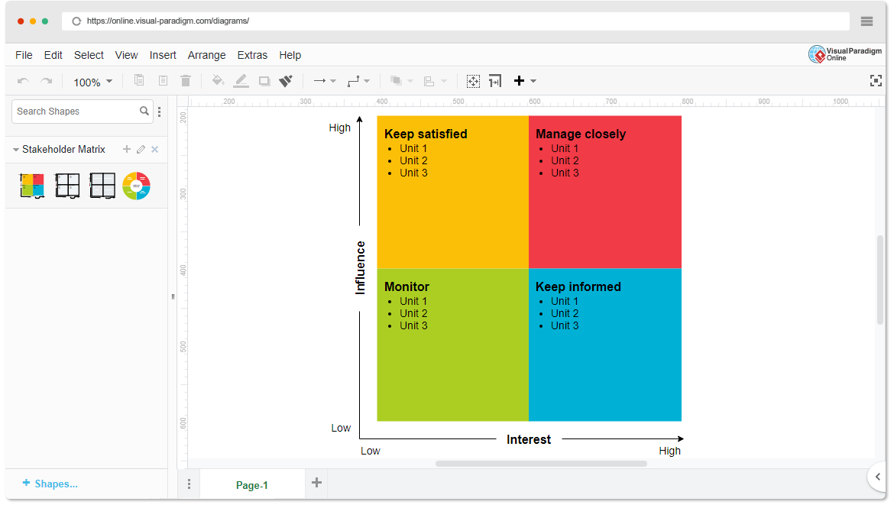

* High Power, High Interest: [Stakeholder Names]
* High Power, Low Interest: [Stakeholder Names]
* Low Power, High Interest: [Stakeholder Names]
* Low Power, Low Interest: [Stakeholder Names]

1. **Empathetic Interviews**

**Conduct Skilled interview with at least 30 citizens/Users by asking open ended questions (What, why/How etc) and list the insights as per the format below**

|  |  |  |
| --- | --- | --- |
| **I need to know**  **(thoughts, feelings, actions)** | **Questions I will ask**  **(open questions)** | **Insights I hope to gain** |
| Thoughts | **What specific innovations does NEBULA aim to promote within the built environment?** | **Fostering collaboration among innovation clusters.** |
| 1. Embrace the journey, for the path is often more rewarding than the destination. | **How will the project measure the success** | **Improving access to funding opportunities.** |
| Building strong networks among innovation clusters fosters knowledge sharing and accelerates progress | **What strategies will be used to ensure effective collaboration** | **Increasing visibility of innovative solutions.** |
| Feelings |  |  |
| 1. **Frustration over slow implementation progress.** | **How does NEBULA plan to enhance access to funding for participating clusters?** | **Encouraging community involvement in projects.** |
| **Hope for a sustainable future** | **How does NEBULA plan to enhance access to funding for participating clusters?** | **Enhancing sustainability in built environments.** |
| actions |  |  |
| **Cross-Sectoral Peer Learning:** | **What role do community members play in the implementation of NEBULA's initiatives?** | **Supporting technological and social innovations.** |
| **Maturity Push Activities:** | **What are the expected long-term impacts of NEBULA** | **Increasing visibility of innovative solutions.** |

**SKILLED INTERVIEW REPORT**

**(Examples are given. Erase them and fill with your user information.)**

|  |  |  |
| --- | --- | --- |
| **User/Interviewee** | **Questions Asked** | **Insights gained (NOT THEIR ANSWERS)** |
| Abhishek Verma,  Student | Which party do you vote for? | Citizens are not very open about their political preferences |
| Srinivasan P., Parent | How do you feel about the plans for a new capital? | Some citizens are sad that the capital is being relocated from Hyderabad. |
|  |  |  |
|  |  |  |
|  |  |  |

**Key Insights Gained:**

* **Insight 1**
* **Insight 2**

**Empathy Map**

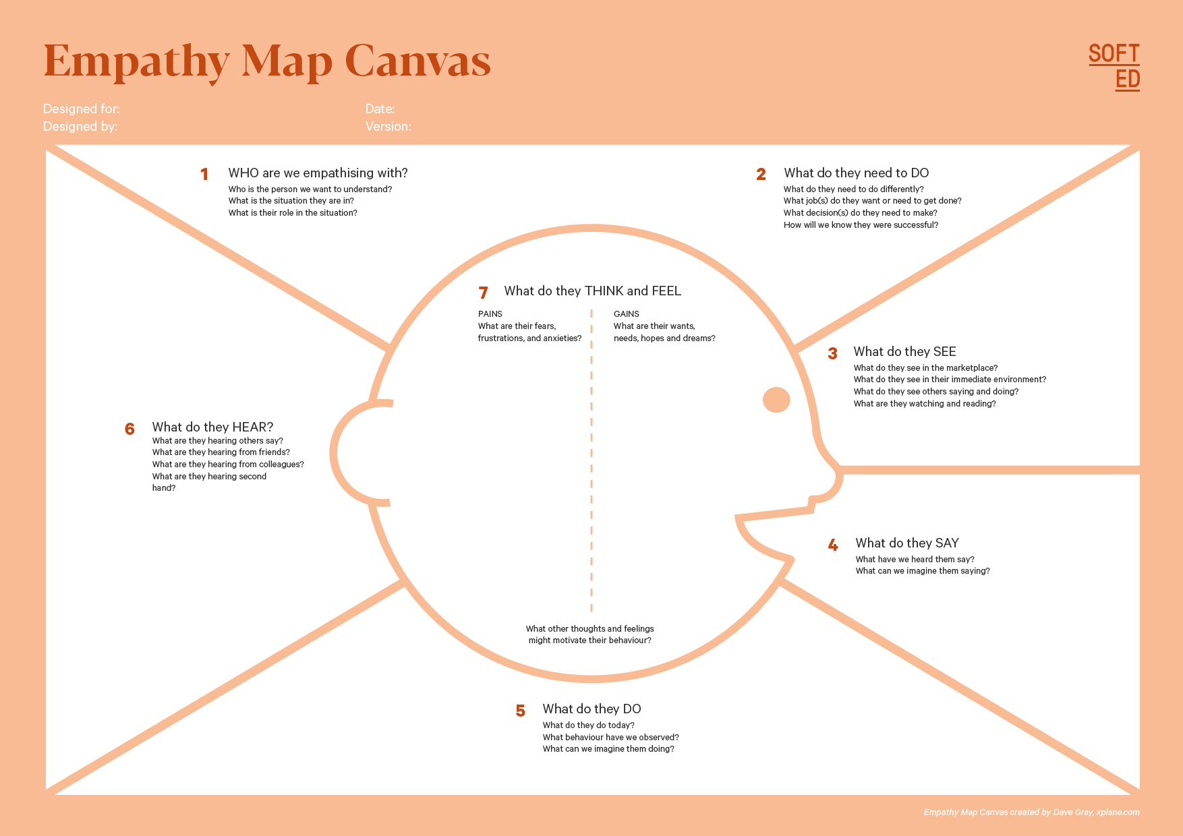

Your Answer: **Benefits of Innovation:**

Your Answer: **Industry Stakeholders**

**Construction industry stakeholders**Segment:

NEBULA : A PYTHON BASED VIRTUAL ASSISTANT

Designed By:

Date of Submission:

Your Answer: **Optimism about Sustainable Solutions**

Your Answer: **Concern Over Implementation Challenges**

Your An **Celebrate Small Wins**swer:

Your Answer: **Access Funding Resources**

Your Answer: **Focus on Sustainability:**

Your Answer: **Celebrate Small Wins**

* Your Answer: Accelerate the deployment and scaling of new sustainable solutions in the built environment sector

1. **Empathy Map**
2. **Who is your Customer?**

**Description: This is where you specify the customer or user you are empathizing with. It could be a specific user persona or a general user segment.**

**Key points:**

* **Define the customer profile clearly (e.g., age, profession, interests).**
* **State their goals and needs related to the innovation or product.**
* **Context in which the user will interact with your solution.**

1. **Who are we empathizing with?**

**Description: This area helps you define who the user is, what their situation looks like, and what role they play. It emphasizes understanding the user’s perspective in depth.**

**Key points:**

* **Define the user's characteristics (e.g., personality, values, and responsibilities).**
* **State the user's goals and challenges in their environment.**
* **What is the user's broader situation (professionally or personally)?**

1. **What do they need to DO?**

**Description: This section identifies what actions or tasks the user needs to perform. It helps highlight the expectations and demands the user faces.**

**Key points:**

* **Clarify the tasks or actions the user needs to complete.**
* **What decisions do they need to make?**
* **How do they define success or failure in their tasks?**

1. **What do they SEE?**

**Description: This focuses on the visual stimuli or environment that the user interacts with. It's important to consider what users see in their immediate surroundings and in their larger world.**

**Key points:**

* **What do users see in their physical and digital environment?**
* **What trends or competitors do they notice?**
* **How do these visual elements influence their behavior?**

1. **What do they SAY?**

**Description: This section captures what the user might say in public, such as comments or feedback they give in conversations or on social media.**

**Key points:**

* **What might users express openly in conversation about their problems?**
* **How do they express their goals or frustrations?**
* **What are their words during customer interviews or feedback?**

1. **What do they DO?**

**Description: This section focuses on what the user does, the actual behaviors they exhibit, and actions they take in different situations.**

**Key points:**

* **What observable actions do users take?**
* **What habits or routines do they follow?**
* **What might users do to try and solve their problems?**

1. **What do they HEAR?**

**Description: This addresses what information the user receives from external sources, such as colleagues, media, or industry trends. It helps map the influences surrounding the user.**

**Key points:**

* **What are they hearing from peers, mentors, or the industry?**
* **What media or channels of information are they exposed to?**
* **Are there any strong influencers guiding their behavior?**

1. **What do they THINK and FEEL?**

**Description: This is one of the most insightful sections, addressing the internal emotions, concerns, and motivations of the user. It helps identify their deep-rooted feelings.**

**Key points:**

* **What are their fears, worries, and anxieties?**
* **What are their motivations and desires?**
* **How do their thoughts and feelings align with their actions?**

1. **Pains and Gains**

**Description: This section focuses on the user’s frustrations and their desired outcomes. It helps to frame the user’s challenges (pains) and the benefits they seek (gains).**

**Key points:**

* **What are the user’s main pain points?**
* **What would make their life easier or more fulfilling?**
* **What benefits do they hope to achieve from your product or solution?**

**8. Persona of Stakeholders**

**Stakeholder Name:**

**Demographics: Key characteristics of your target audience, such as age, gender, income, and location.**

**oung People (18-25 years old):**

**Youth Workers and Leaders:**

**Cultural Heritage Actors:**

**Goals: What the stakeholders or customers want to achieve in relation to the innovation.**

**Empower Young Entrepreneurs**

**Facilitate Networking and Collaboration**

**Increase Visibility of Innovations**

**Challenges: The obstacles or difficulties faced by stakeholders that the innovation aims to address.**

**Lack of Visibility for Innovations**

**Limited Access to Funding**

**Aspiration: The long-term desires or dreams of your target audience related to the innovation.**

**Sustainable Community Revitalization**

**Empowerment through Entrepreneurship**

**Needs: The essential requirements of your customers or stakeholders that must be met**

**Networking and Collaboration**

**Visibility of Innovations.**

**Pain Points: Specific problems or frustrations experienced by the target audience.**

**Limited Engagement Opportunities for Youth**

**Fragmented Network**

**Storytelling: A narrative that highlights the journey of the stakeholder or customer, illustrating the problem and how the innovation can solve it.**

**Sofia has always been passionate about her community and dreams of revitalizing the neglected public spaces around her. However, she faces several challenges that make her ambitions feel out of reach.**

**The Problem: Feeling Disconnected and Unsupported**

**Despite her enthusiasm, Sofia feels isolated. There are limited opportunities for young people like her to engage in meaningful projects that can bring about change. She often hears from her friends about their frustrations with the lack of funding and resources available for innovative ideas. Many of them have given up on their dreams, believing that they cannot make a difference without support.Sofia also notices how disconnected local organizations are; they rarely collaborate or share resources. This fragmentation leaves her feeling overwhelmed and unsure of where to start. She knows that the community needs revitalization, but she lacks the guidance and mentorship to turn her vision into reality.**

**Sample:**

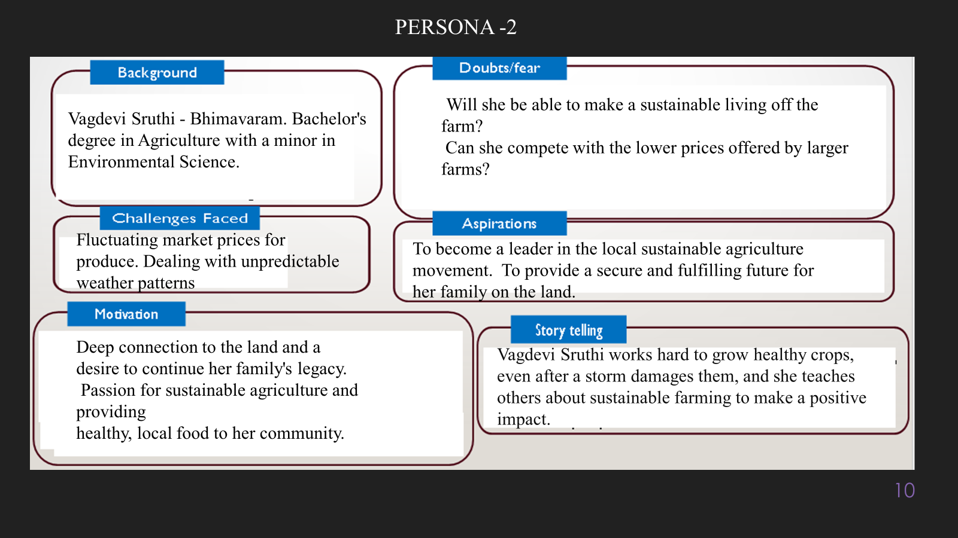

**10. Look for Common Themes, Behaviors, Needs, and Pain Points among the Users**

Analyse the data from your affinity diagram to uncover recurring patterns among your users, helping you better understand their expectations and challenges.

**Common Themes: Identify broad ideas or issues that repeatedly appear across different groups in your affinity diagram.**

**Cross-Sectoral Cooperation**

**Shared Resources**

**Common Behaviors: Observe how users consistently act or respond in relation to the problem or product throughout their journey.**

**Increased Engagement in Collaborative Settings**

**Preference for Intuitive Interfaces**

**Common Needs: Pinpoint essential requirements or desires that many users share, highlighting what they need for a better experience.**

**Access to Funding and Resources**

**User-Friendly Interfaces**

**Common Pain Points: Look for frustrations or obstacles that frequently hinder the user experience, which your project can address.**

**Lack of Access to Funding and Resources**

**Insufficient Collaboration and Networking Opportunities**

**12. Define Needs and Insights of Your Users**

* **User Needs: Define the core requirements your users have in relation to the problem or product. These could be functional, emotional, or societal needs that your solution must address. Access to Funding and Resources: Users require improved access to financial resources and support systems that can help them implement their innovative projects effectively. This includes guidance on navigating funding opportunities.**
* **User-Friendly Interfaces: Users desire intuitive and user-friendly interfaces that facilitate easy navigation and interaction. Poorly designed interfaces that are inconsistent or overly cluttered can significantly hinder the user experience.**
* **Collaboration and Networking Opportunities: Users seek enhanced opportunities for collaboration with other stakeholders, including innovators, youth workers, and community members**

**User Insights: Summarize the key understandings or observations you've uncovered about your users' behaviors, motivations, and pain points. These insights provide a deeper understanding of why users behave the way they do and what drives their decisions.**

* **Increased Engagement in Collaborative Settings: Users demonstrate a tendency to engage more actively when participating in collaborative platforms like NEBULA, indicating the value they place on peer interaction and knowledge sharing.**
* **Preference for Intuitive Interfaces: Users consistently express a preference for user-friendly interfaces that facilitate easy navigation and interaction, suggesting that simplicity and accessibility are important factors in their experience.**
* **Community-Centric Approach: Stakeholders consistently advocate for involving community members in discussions about urban development and sustainability initiatives**

**13. POV Statements**

**POV Statements:**

* [User] needs a way to [need] because [insight].

|  |  |  |  |
| --- | --- | --- | --- |
| PoV Statements  (At least ten) | Role-based or Situation-Based | Benefit, Way to Benefit,  Job TBD,  Need (more/less) | PoV Questions  (At least one per statement) |
| 1. Mentorship Access 2. Training Programs 3. Visibility Tools 4. Data Insights 5. Community Participation 6. Funding Navigation 7. Practice Sharing 8. Collaboration Opportunities 9. Impact Metrics 10. Curriculum Resources | ROLE BASED | **Improved Access to Funding and Resources**  **Enhanced Collaboration and Networking**  **Increased Visibility for Innovations** | 1. **How might we improve mentorship access for young entrepreneurs in our community?** 2. **How might we develop effective training programs for youth workers focused on sustainability practices?** 3. **How might we create visibility tools that help cultural heritage organizations promote their initiatives?** 4. **How might we provide data insights that local government officials need to understand community preferences?** 5. **How might we facilitate greater community participation in urban development discussions?** 6. **How might we streamline the process for funding navigation to make it easier for innovators?** 7. **How might we establish platforms for practice sharing among environmental activists to inspire collective action?** 8. **How might we foster collaboration opportunities between researchers and practitioners in the field?** 9. **How might we develop clear impact metrics that financial institutions can use to measure project success?** 10. **How might we provide valuable curriculum resources for educators to incorporate sustainability into their teaching?**   These questions can guide ideation and solution development, helping to address the needs and insights of various stakeholders involved in the NEBULA project.  Share  Rewrite  Related  How can POV statements be used to differentiate a brand  What are some examples of successful POV statements  How do POV statements impact brand perception  What role do POV statements play in marketing strategies  How can companies create effective POV statements  Search Images  Search Videos  Generate Image |
|  |  |  |  |
|  |  |  |  |
|  |  |  |  |
|  |  |  |  |

**14. Develop POV/How Might We (HMW) Questions to Transform Insights/Needs into Opportunities for Design**

Turn your user needs and insights into actionable opportunities by framing them as "How Might We" (HMW) questions. These questions will spark creative problem-solving and guide your innovation process.

**How Might We: Based on the needs and insights you've identified, create open-ended questions starting with "How might we...?" These questions should aim to solve user pain points, enhance the experience, or address specific needs.**

**How might we improve mentorship access for young entrepreneurs to help them successfully launch their sustainable projects?**

**How might we design effective training programs for youth workers that equip them with the skills needed to support community engagement?**

**Write 3-5 "How Might We" questions based on your analysis of user needs and insights. These questions should challenge you to think of innovative solutions that can address user problems in meaningful ways.**

1. **How might we leverage technology to enhance mentorship access for young entrepreneurs, connecting them with experienced professionals in real-time?**
2. **How might we create interactive and engaging training programs for youth workers that utilize gamification to improve learning outcomes related to sustainability?**
3. **How might we develop a centralized online platform that allows cultural heritage organizations to showcase their initiatives and engage the community effectively?**

**This task encourages participants to think creatively about solving user problems, transforming challenges into opportunities for innovation.**

|  |  |
| --- | --- |
| User Need/Insight | "How Might We" Question |
| [State the user need or insight clearly] | **How might we... [formulate an open-ended question to address the need or insight]?** |

**16. Crafting a Balanced and Actionable Design Challenge**

The Design Challenge Should Neither Be Too Narrow Nor Too Broad and It Should Be an Actionable Statement with a quantifiable goal. It should be a culmination of the POV questions developed.

* **Specific**: The challenge focuses on creating a digital platform specifically for young entrepreneurs.
* **Measurable**: The goal is quantifiable—aiming for a 30% increase in project implementation success rates.
* **Actionable**: The statement provides a clear direction for action, focusing on mentorship, funding, and community resources.
* **Relevant**: This challenge directly addresses the identified needs of young entrepreneurs and stakeholders involved in the NEBULA project.
* **Time-bound**: The goal is set to be achieved within one year.

**17. Validating the Problem Statement with Stakeholders for Alignment**

Ensure your problem statement accurately represents the needs and concerns of your stakeholders and users. This involves gathering feedback from these groups to confirm that the problem is relevant and significant from their perspective. By validating early, you can refine the problem statement to better align with real-world challenges, ensuring your solution addresses the correct issues.

**Validation Plan:**

**Identify Key Stakeholders**

* Determine the primary stakeholder groups that will be impacted by the solution, such as young entrepreneurs, youth workers, cultural heritage organizations, and local government officials.

**2. Conduct Interviews and Focus Groups**

* Engage with representatives from each stakeholder group through interviews and focus groups to gather their feedback on the problem statement.
* Discuss the relevance of the problem, its significance to their work, and any additional needs or concerns they may have.

**18. Ideation**

| **Idea Number** | **Proposed Solution** | **Key Features/Benefits** | **Challenges/Concerns** |
| --- | --- | --- | --- |
| **Idea 1** | **Mentorship Matching Platform** | **- Connects young entrepreneurs with experienced mentors based on interests and goals. - Offers virtual meeting tools and resources for mentorship sessions.** | **- Ensuring mentor availability and commitment. - Matching quality may vary based on user profiles.** |
| **Idea 2** | **Funding Resource Hub** | **- Centralized database of funding opportunities tailored to specific projects. - Includes application guides and success stories to inspire users.** | **- Keeping the database updated with accurate information. - Users may still face challenges in the application process.** |
| **Idea 3** | **Community Engagement Workshops** | **- Interactive workshops that bring together community members, innovators, and local officials to discuss project ideas. - Facilitates collaboration and feedback on proposed initiatives.** | **- Participation may vary; some community members might be hesitant to engage. - Scheduling conflicts could limit attendance.** |
| **Idea 4** | **Impact Assessment Toolkit** | **- Provides tools for measuring the social and environmental impact of projects. - Offers templates and guidelines for reporting results to funders.** | **- Users may lack the expertise to effectively use the toolkit. - Resistance to sharing impact data due to privacy concerns.** |
| **Idea 5** | **Online Learning Platform for Sustainability** | **- Offers courses and resources on sustainable practices tailored for youth workers and entrepreneurs. - Includes certifications that can enhance professional credibility.** | **- Ensuring course content remains relevant and engaging. - Users may face time constraints in completing cours** |

| **Idea** | **Impact (10/100/1000 grams)** | **Feasibility (10/100/1000 grams)** | **Alignment (10/100/1000 grams)** | **Total Weight** |
| --- | --- | --- | --- | --- |
| **Idea 1: Mentorship Matching Platform** | **1000 grams** | **100 grams** | **1000 grams** | **2100 grams** |
| **Idea 2: Funding Resource Hub** | **1000 grams** | **1000 grams** | **1000 grams** | **3000 grams** |
| **Idea 3: Community Engagement Workshops** | **100 grams** | **100 grams** | **1000 grams** | **1200 grams** |
| **Idea 4: Impact Assessment Toolkit** | **1000 grams** | **100 grams** | **1000 grams** | **2100 grams** |
| **Idea 5: Online Learning Platform for Sustainability** | **1000 grams** | **10** |  |  |

**Solution Concept Form**

**1. Problem Statement:**

**Innovators in the built environment face significant challenges in accessing funding, resources, and collaborative opportunities, which hinders their ability to implement sustainable and people-centric solutions effectively."**

**2. Target Audience:**

**Innovators and customers**

**3. Solution Overview:**

1. **Mentorship Matching: Connecting innovators with experienced professionals who can provide guidance and support throughout their project development process.**

**4. Key Features:**

| **Feature** | **Description** |
| --- | --- |
| **Feature 1** | **[Mentorship Matching**  **]** |
| **Feature 2** | **Funding Resource Hub** |
| **Feature 3** | **Funding Resource Hub**  **]** |

**5. Benefits:**

| **Benefit** | **Description** |
| --- | --- |
| **Benefit 1** | **[Enhanced Access to Resources**  **?]** |
| **Benefit 2** | **[Improved Project Success Rates** |
| **Benefit 3** | **Community-Centric Approach** |

**6The NEBULA digital platform uniquely combines mentorship, funding access, and community engagement into a single, user-friendly solution tailored specifically for innovators in the built environment.**

**7. Key Metrics:**

| **Metric** | **Measurement** |
| --- | --- |
| **Metric 1** | **[Project Implementation Success Rate**  **?]** |
| **Metric 2** | **[ Community Engagement Level** |

**8. Human Resources: The development of the platform will require a multidisciplinary team, including software developers, UX/UI designers, project managers, and subject matter experts in sustainability and community engagement.**

**9. Next Steps:**

1. **Define Project Scope and Requirements**
   * **Clearly outline the goals, features, and functionalities of the digital platform based on stakeholder feedback and identified needs. This includes detailing user personas, target audience, and success criteria.**
2. **Assemble a Development Team**